NFC-IET UNIVERSITY, MULTAN



LAB REPORT

ICT (“Information & Communication Technology Fundamental”)

For the degree of Bacheller of Science

In Computer Science

Session [2k24]

Name Laiba Syed

Roll NO (2k24-BSCS-455)

Section Y

Submitted To: Ms. Fabia Hassan

Submitted By: Laiba Syed

**Assignment**

**LAB 1**

**Typing Practices and Internal components of Computer.**

* **Typing practices:**

1. **Set Goals**
   1. **Speed**: Aim for 40–60 WPM (words per minute) for beginners, and 60–80+ WPM for advanced users.
   2. **Accuracy**: Focus on reducing errors, aiming for 95–98% accuracy.
2. **Use Typing Tools**
   1. **Web-based Typing Tutors**: Websites like [Typing.com](https://www.typing.com/), [Keybr.com](https://www.keybr.com/), or [10fastfingers.com](https://10fastfingers.com/).
   2. **Software**: Tools like Typing Master or Rapid Typing provide detailed lessons and analysis.
3. **Practice Regularly**
   1. Allocate 15–30 minutes daily to typing exercises.
   2. Focus on proper finger placement: use the **home row keys** (A-S-D-F for the left hand and J-K-L-; for the right hand).
4. **Monitor Progress**
   1. Take typing speed and accuracy tests regularly to track improvement.
5. **Posture and Ergonomics**
   1. Sit straight with feet flat on the ground.
   2. Ensure wrists are straight and fingers are relaxed while typing.
   3. Use a comfortable, ergonomic keyboard if possible.

* **Internal components of a computer:**
* **Processor (CPU-central processing unit)**

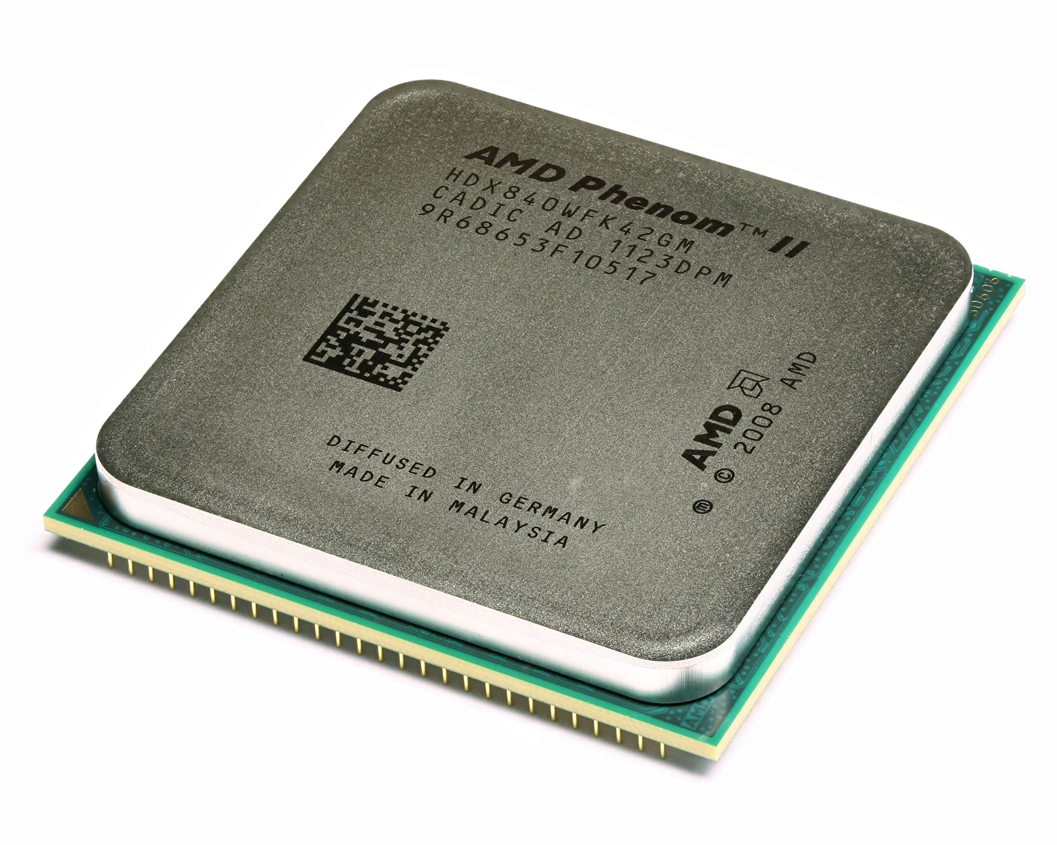

1. **Function**: The "brain" of the computer; it performs calculations and executes instructions.
2. **Key Parts**:
   * **Cores**: Modern CPUs have multiple cores (dual-core, quad-core, etc.) for multitasking.
   * **Clock Speed**: Measured in GHz, it indicates how fast the CPU can process data.

* **Motherboard**

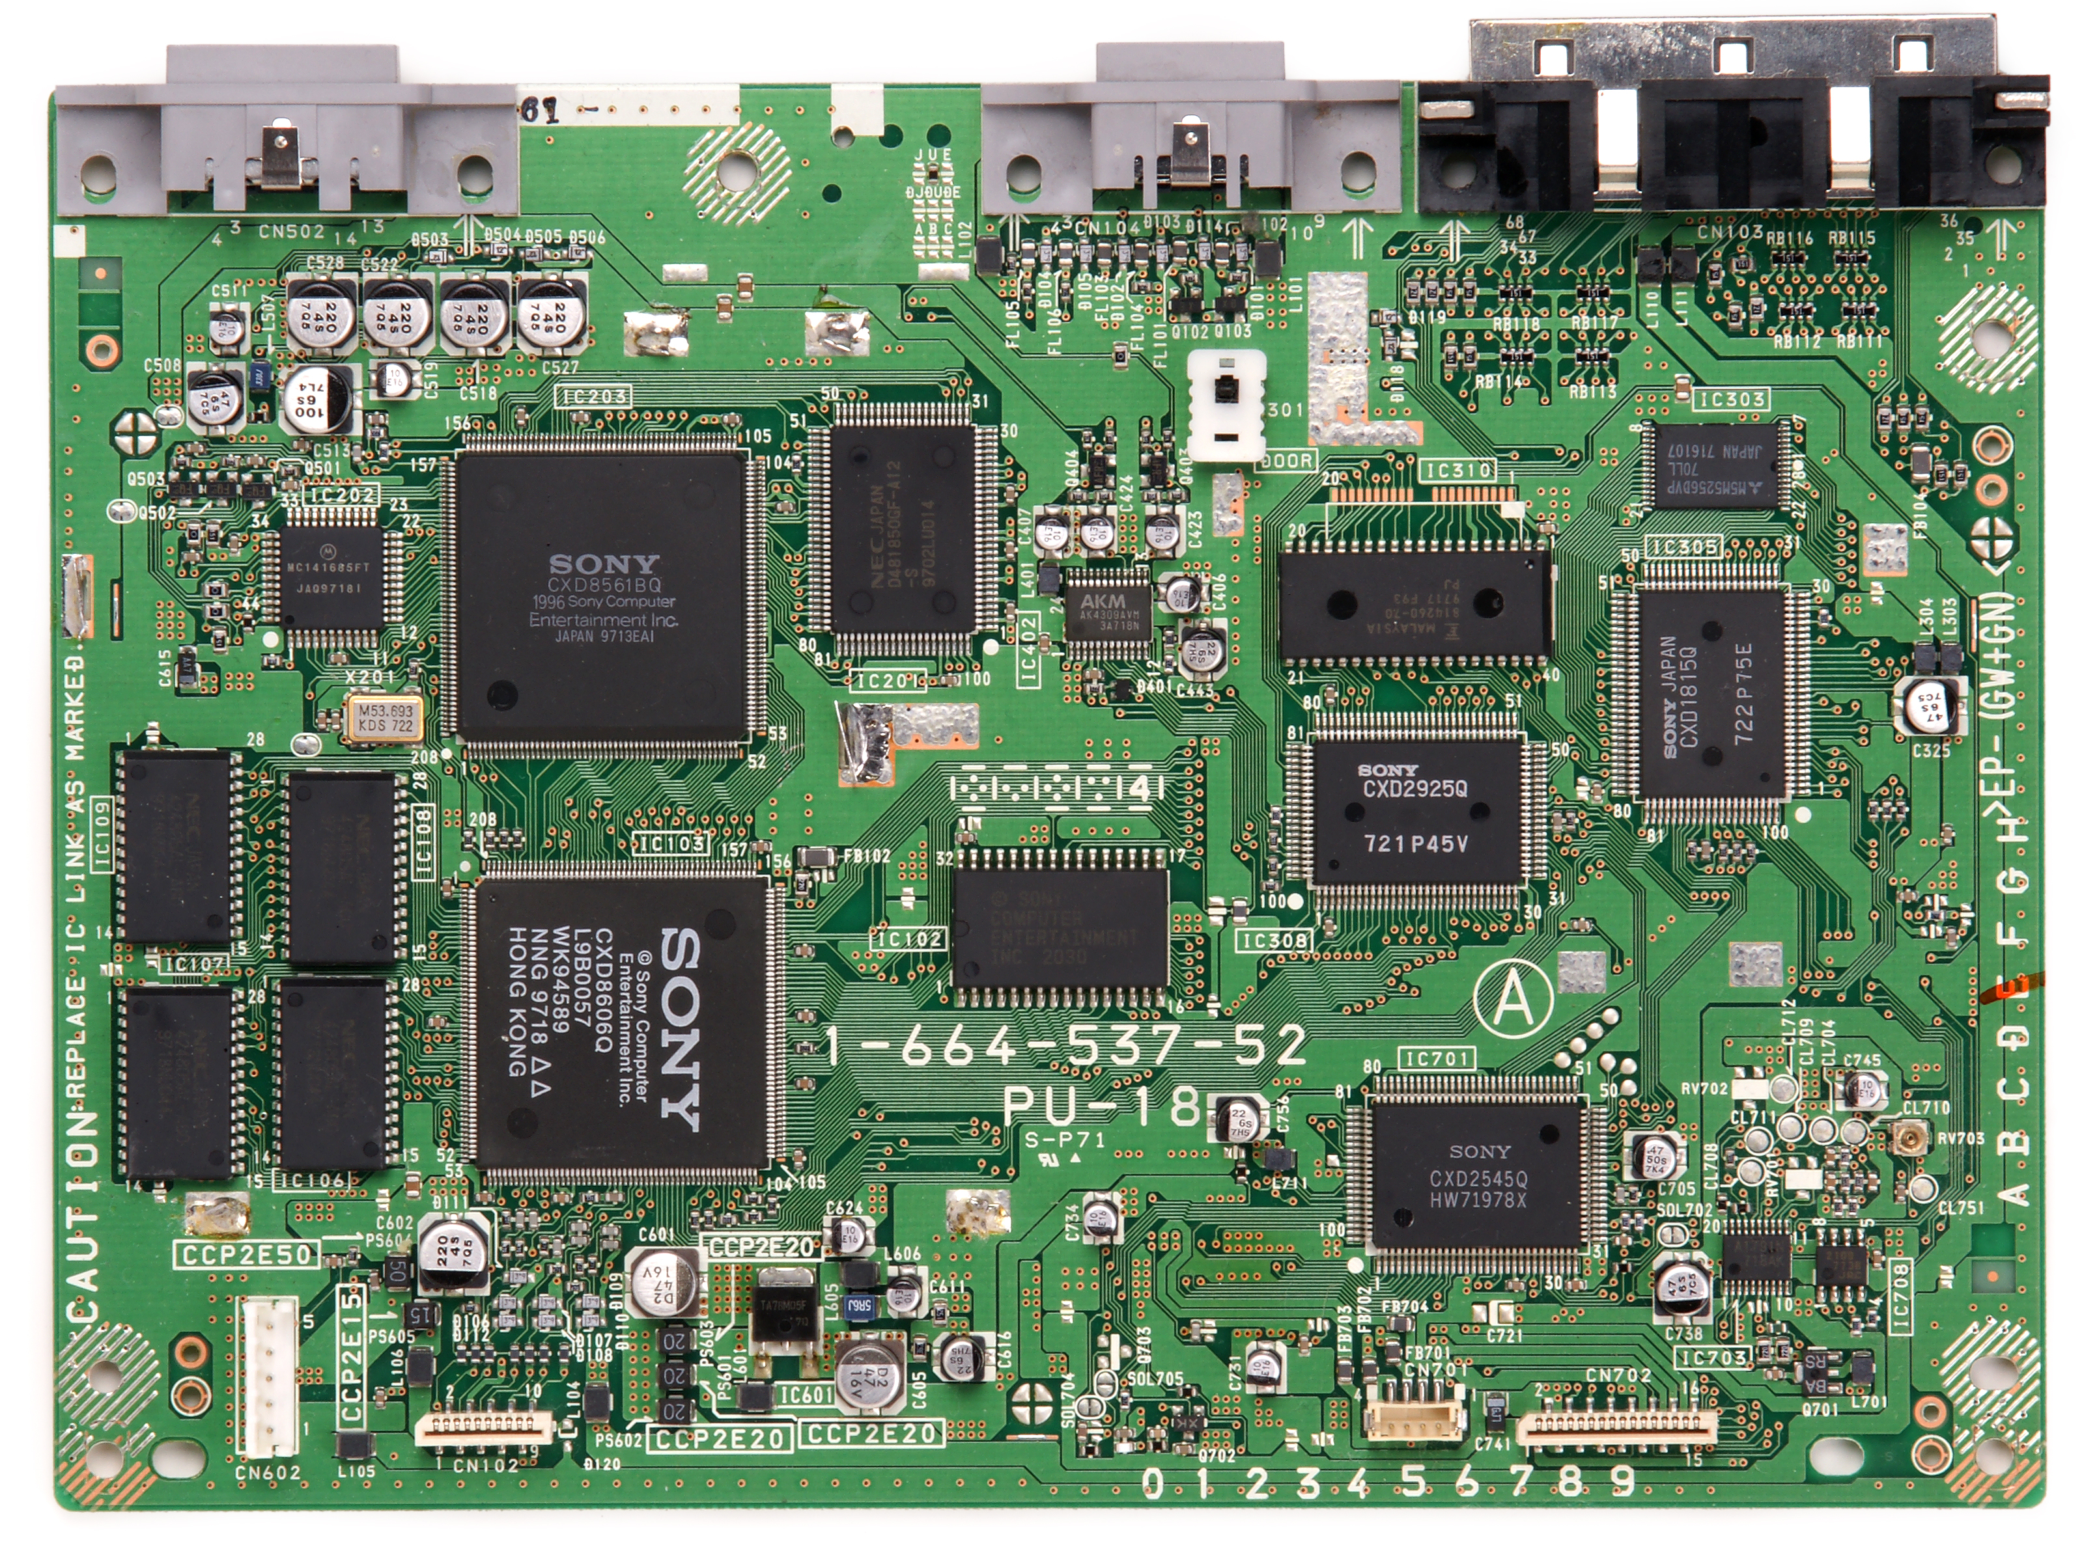

1. **Function**: The main circuit board that connects all components.
2. **Key Parts**:
3. CPU socket, RAM slots, PCIe slots (for GPUs and expansion cards), and ports for storage devices.

* **Storage devices**

1. **HDD (Hard Disk Drive)**: Older, slower storage with larger capacity.

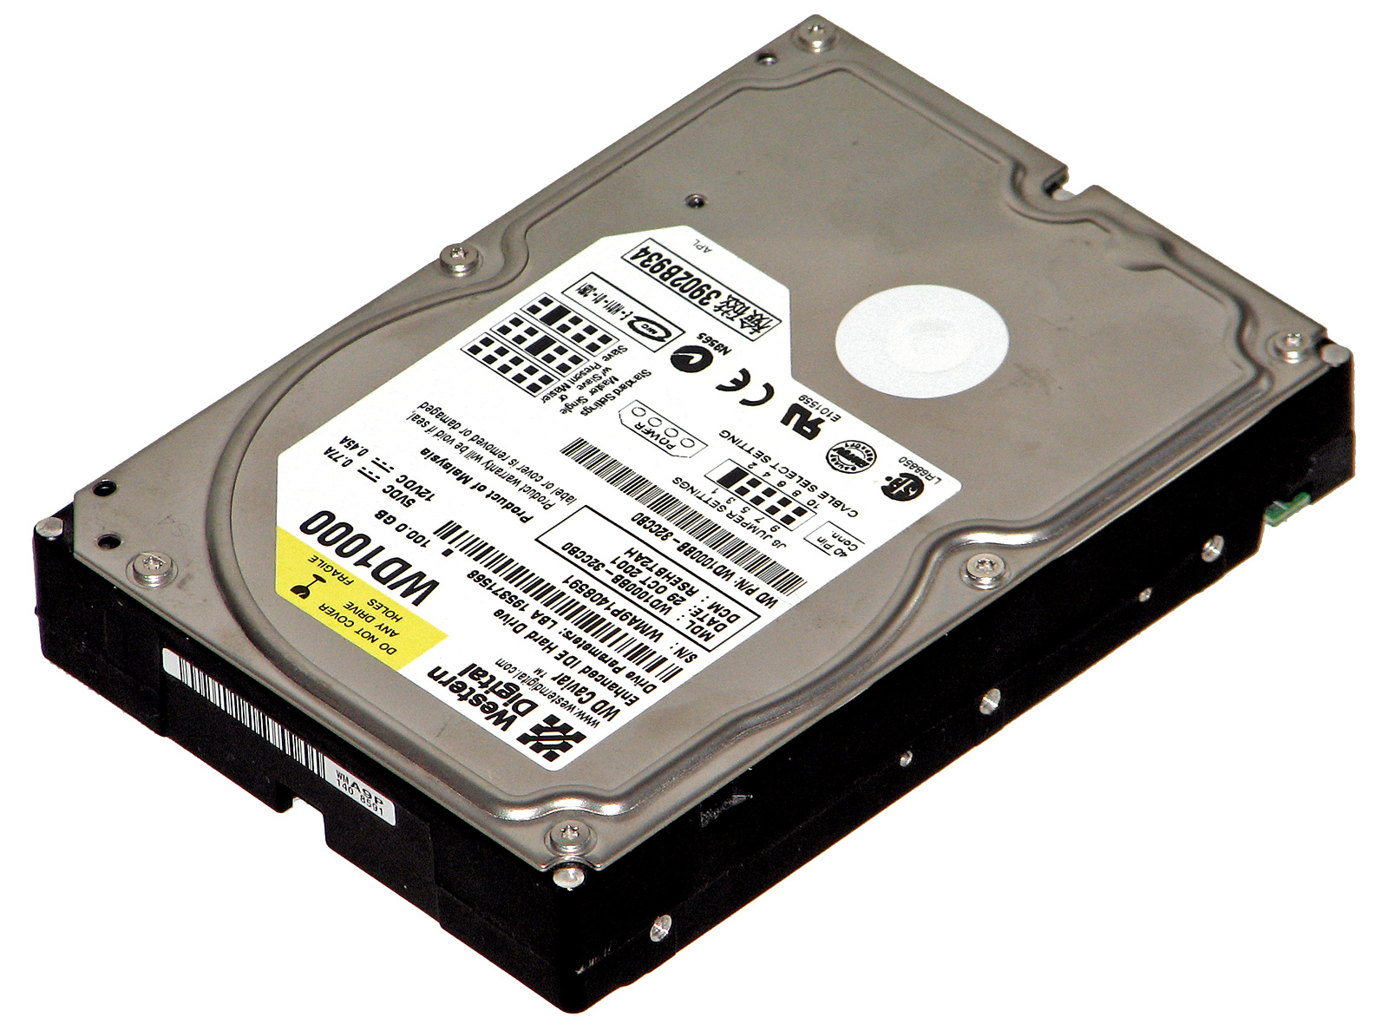

1. **SSD (Solid State Drive)**: Faster, more reliable storage but generally more expensive.
2. **M.2 or NVMe Drives**: Advanced, high-speed SSDs.

* **Power Supply Unit**

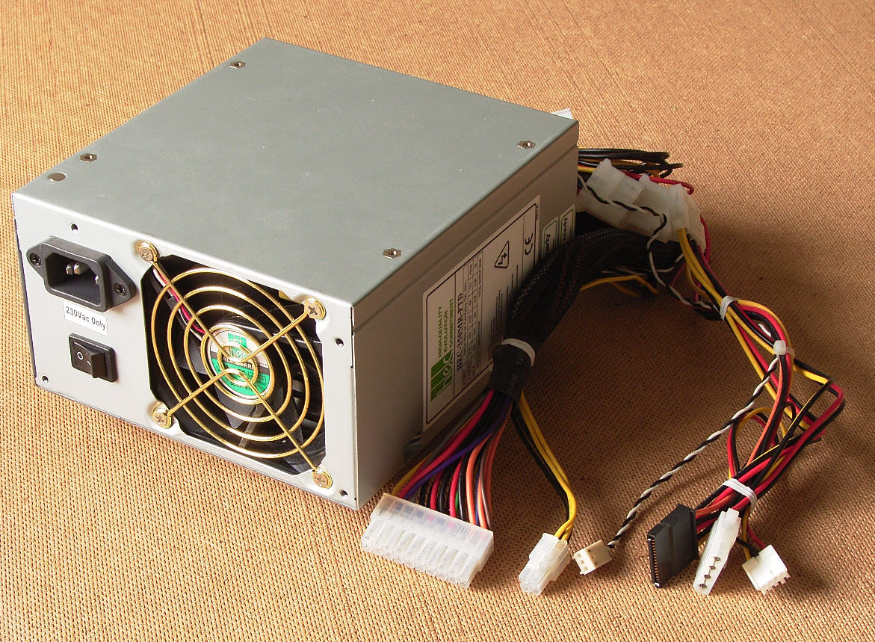

1. **Function**: Provides power to all components.
2. **Rating**: Measured in watts, e.g., 500W, 650W.

* **Graphics Processing Unit**

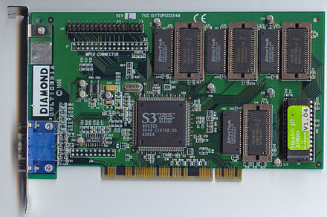

1. **Function**: Handles graphics and video rendering tasks. Essential for gaming, video editing, and AI processing.
2. **Types**: Integrated (built into the CPU) and Dedicated (separate cards, like NVIDIA or AMD GPUs).

* **Cooling System**

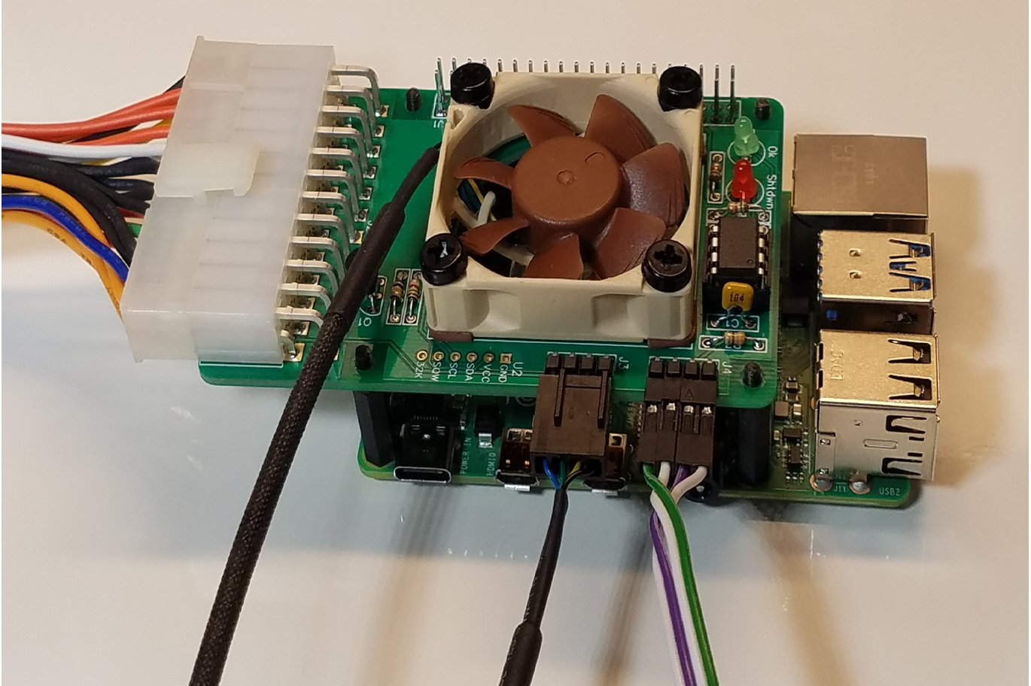

1. **Types**:
2. Air Cooling: Fans and heatsinks.
3. Liquid Cooling: For high-performance setups.
4. **Function**: Prevents overheating of CPU, GPU, and other components.

* **Input/Output ports**

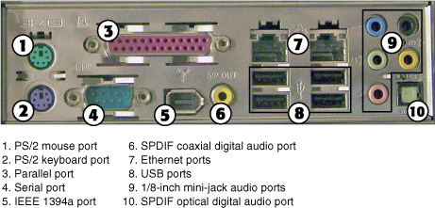

1. Examples: USB ports, HDMI, Ethernet, Audio jacks.

* **ROM (Read-Only Memory)**

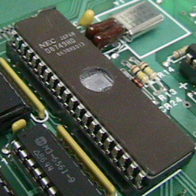

1. **Function**: Stores firmware, such as the BIOS or UEFI, which initializes hardware during startup.

* **Network Interference Card**

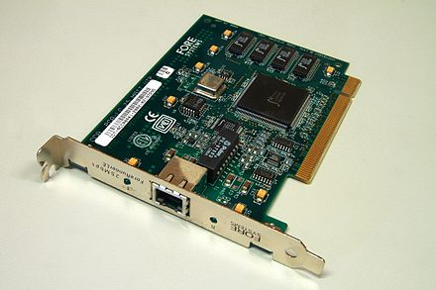

1. **Function**: Connects the computer to the internet or local network (wired or wireless).

**LAB 2**

**Windows installation and CPU assembling**

* **Window installation:**
* **Requirements**

1. A computer meeting the minimum system requirements for the version of Windows (e.g., Windows 10, 11).
2. A bootable Windows installation media:
   1. **USB Drive** (minimum 8GB) created using the [Windows Media Creation Tool](https://www.microsoft.com/software-download/).
   2. **DVD** if your system has a DVD drive.
3. A valid Windows product key (if required).

* **Backup Data**

1. Back up all important data on the system, as installation may erase existing files.

* **Check BIOS Settings**

1. Restart the computer and press the key to enter the BIOS/UEFI (commonly **F2**, **DEL**, or **ESC**).
2. Ensure the following:

* **Boot Order**: Set the USB or DVD drive as the primary boot device.
* **Secure Boot**: Disable this option if required for older installation media.
* **Boot Mode**: Use UEFI or Legacy depending on your system and drive type.
* **Boot from installation Media**

1. Insert the USB drive or DVD into your computer.
2. Restart the computer.
3. When prompted, press a key to boot from the installation media (e.g., "Press any key to boot from USB...").

* **Installation Process**

**Step 1: Language and Region**

* Select your **language**, **time and currency format**, and **keyboard input**.
* Click **Next**, then **Install Now**.

**Step 2: Enter Product Key**

* Enter your Windows product key if prompted.
* If you don’t have one, select **I don’t have a product key** (you can activate later).

**Step 3: Choose Installation Type**

* **Upgrade**: Keeps your files and settings (useful for updating an existing installation).
* **Custom**: For a clean installation (erases all existing data on the selected drive).

**Step 4: Partition the Hard Drive**

* Select the drive where you want to install Windows.
* If needed, delete existing partitions and create a new partition:
  + Highlight the partition, click **Delete**, and confirm.
  + Click **New** to create a new partition and format it.
  + Select the partition labeled **Primary** and click **Next**.

**Step 5: Windows Installation**

* The installer will copy files, install features, and update settings.
* This process may take 10–30 minutes depending on your system.
* **Post-Installation Setup**

**Step 1: Regional Settings**

* Choose your region and keyboard layout.

**Step 2: Connect to a Network**

* Select a Wi-Fi network or connect via Ethernet.

**Step 3: Sign in to Microsoft Account**

* Use your Microsoft account or create a local account.

**Step 4: Customize Settings**

* Choose privacy settings (e.g., location, diagnostics).
* Configure updates and additional preferences.
* **Final Steps**

**Install Drivers**

* Install hardware drivers (graphics, audio, network) from the manufacturer’s website or a driver updater tool.

**Update Windows**

* Go to **Settings > Update & Security > Windows Update** and install the latest updates.

**Install Applications**

* Install essential applications like browsers, antivirus software, and productivity tools.

**Restore Data**

* If you backed up data, restore it to the system.

* **CPU assembling:**
* **Tools required**

1. **Screwdriver**: For securing the motherboard and cooler.
2. **Thermal Paste**: If the CPU cooler does not have pre-applied paste.
3. **Anti-static Wrist Strap**: To prevent static discharge that could damage components.

* **Prepare Your Workspace**
* Ensure you’re working on a clean, flat, and non-conductive surface.
* Wear an anti-static wrist strap or discharge static electricity by touching a grounded object.
* **Identify the Components**

1. **CPU**: The processor you are installing.
2. **Motherboard**: The main circuit board.
3. **CPU Socket**: The area on the motherboard where the CPU is installed.
4. **CPU Cooler**: For dissipating heat generated by the CPU.

* **Steps to Install the CPU:**

**Step 1: Locate the CPU Socket**

Find the CPU socket on your motherboard.

* **Types of CPU Sockets**:
  + **Intel (LGA)**: The pins are on the motherboard socket.
  + **AMD (PGA)**: The pins are on the CPU itself.

**Step 2: Open the CPU Socket**

* Release the retention lever or cover.
* Be gentle to avoid bending any pins or damaging the socket.

**Step 3: Align the CPU**

* Identify the **gold triangle** on the CPU corner and align it with the **triangle marker** on the socket.
* Carefully place the CPU into the socket without applying force. It should fit naturally.

**Step 4: Secure the CPU**

* For **Intel CPUs**: Lower the retention arm or latch to secure the CPU in place.
* For **AMD CPUs**: Lower the socket lever to lock the CPU.
* **Install the CPU Cooler**

**Step 1: Apply Thermal Paste**

* If the cooler does not have pre-applied thermal paste, apply a small pea-sized amount in the center of the CPU.

**Step 2: Mount the Cooler**

* Position the cooler over the CPU and align it with the mounting points on the motherboard.
* Secure it using the provided screws or clips. Follow the manufacturer’s instructions.

**Step 3: Connect the Fan**

* Plug the cooler's fan cable into the **CPU_FAN** header on the motherboard.
* **Verify Installation**

1. Ensure the CPU and cooler are firmly secured.
2. Check for any bent pins or improper alignment.
3. Verify that the fan is connected properly.

* **Continue with Other Components**

Once the CPU is installed, proceed to install other components like RAM, GPU, and storage drives.

### 

**LAB 3**

**Motherboard and its internal structure**

* **Motherboard Overview:**

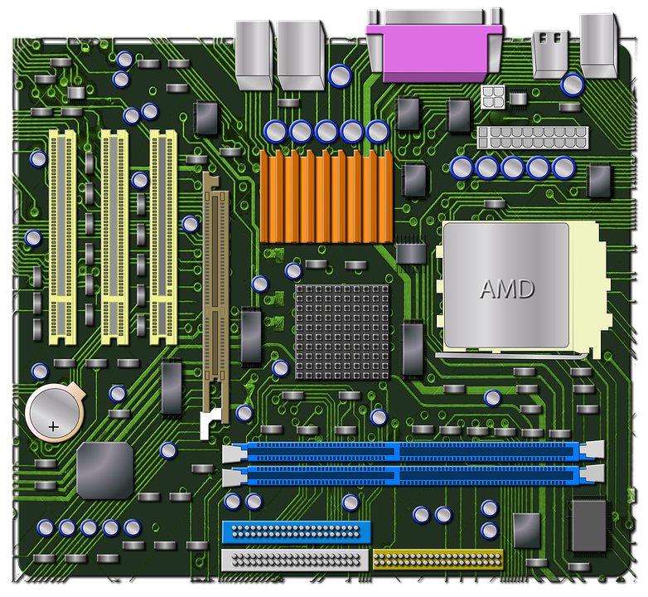

**Motherboard over view:**

The **motherboard** is the main circuit board in a computer. It acts as the central hub that connects all the components and allows them to communicate. It provides the necessary infrastructure for the CPU, RAM, storage devices, and other hardware to function together.

* **Key Function of a Motherboard:**

1. **Power Distribution:** Supplies power to all connected components.
2. **Communication:** Facilitates data transfer between the CPU, memory, storage, and peripherals.
3. **Customization and Expansion:** Offers slots and ports for upgrading and adding hardware.

* **Key components of motherboard:**

1. **CPU Socket**: Slot for installing the processor.

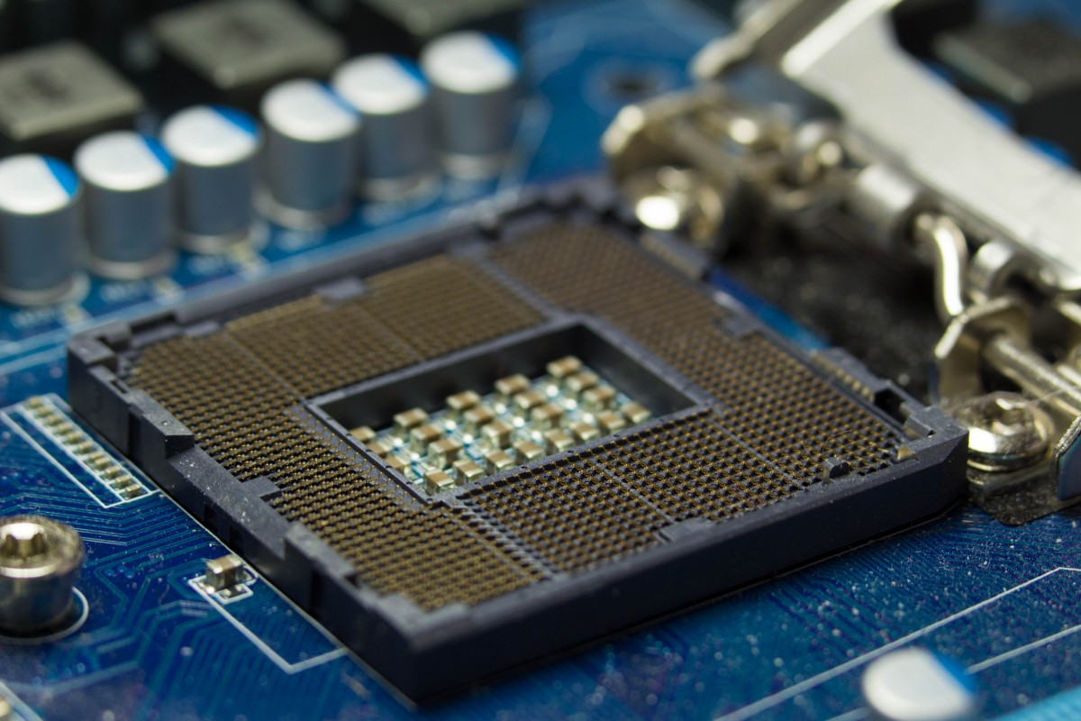

1. **Chipset**: Manages communication between CPU, RAM, and peripherals.

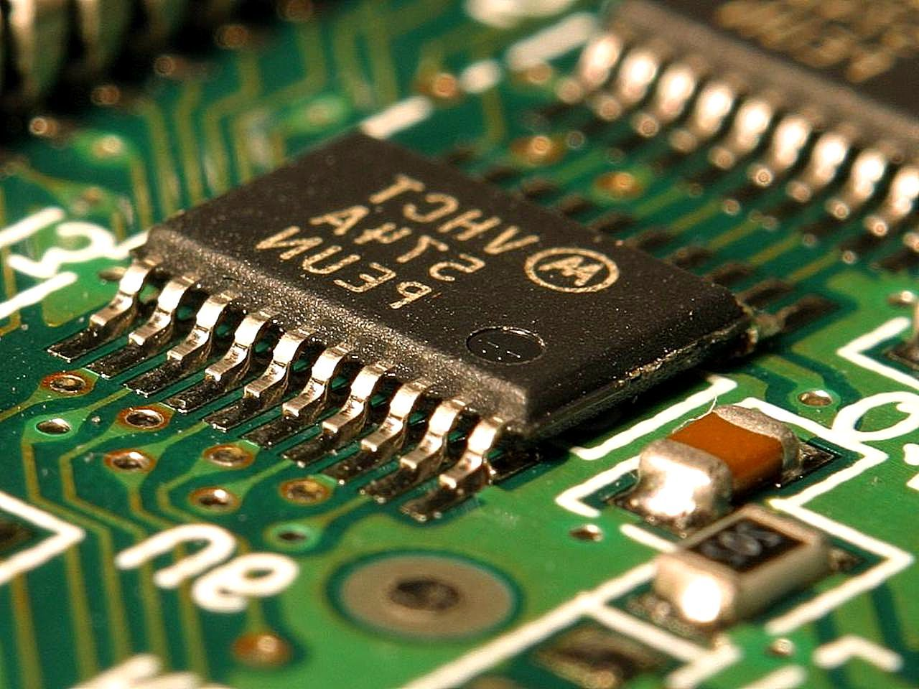

1. **RAM Slots**: Holds memory modules for system memory.

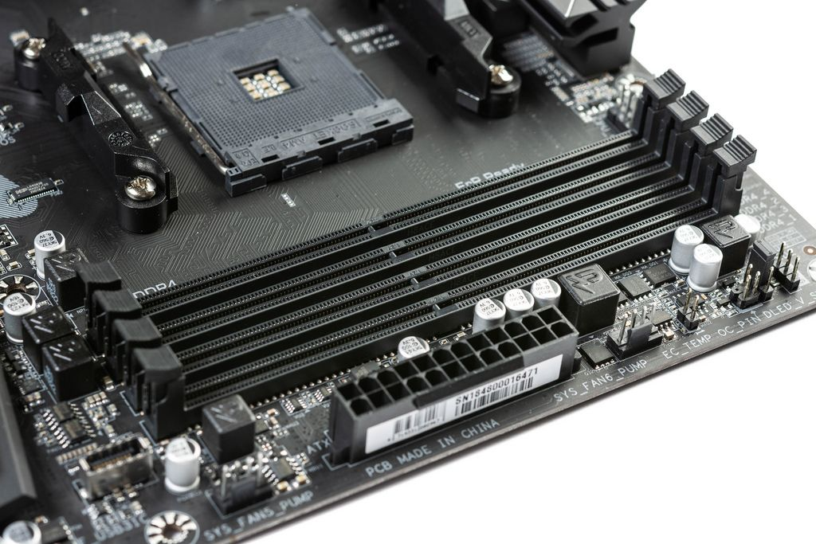

1. **PCIe Slots**: For GPUs, sound cards, or other expansion cards.

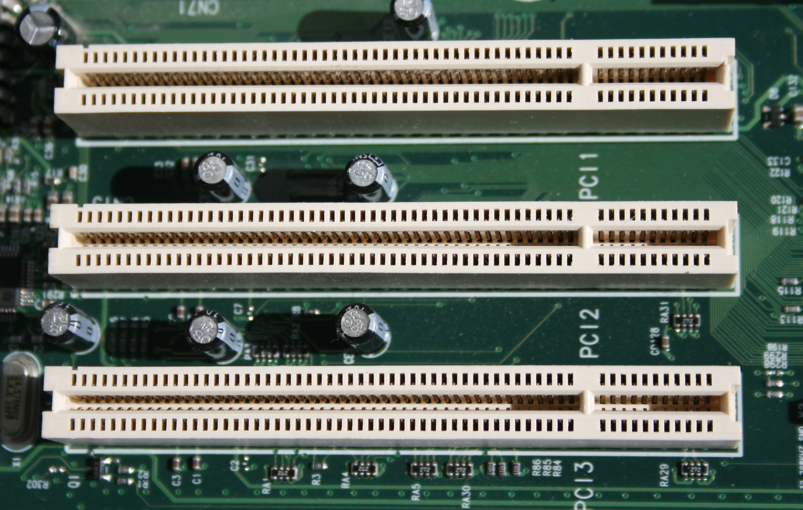

1. **Storage Interfaces**: SATA and M.2 slots for connecting HDDs, SSDs.

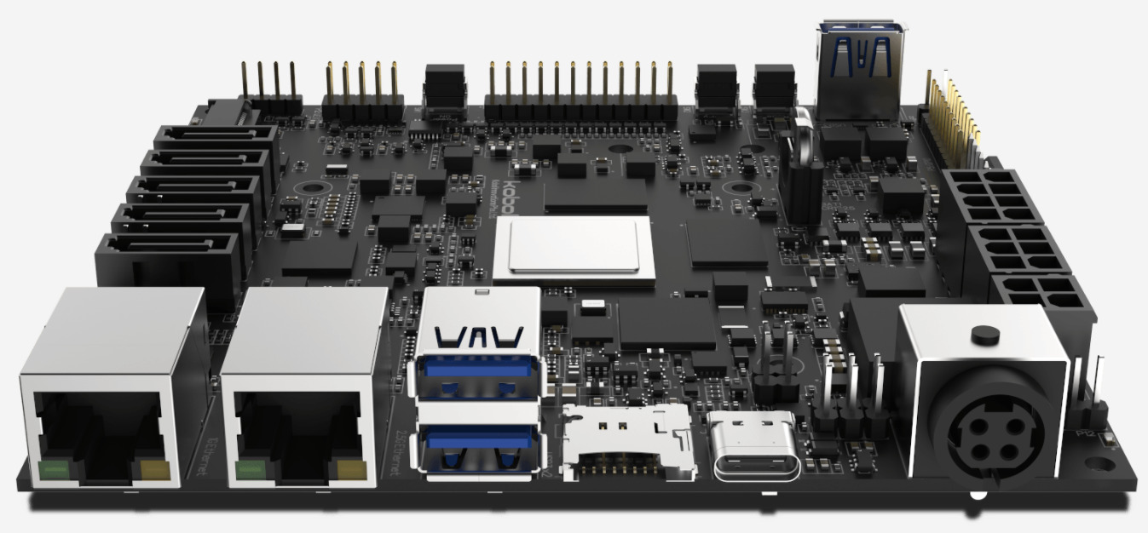

1. **Power Connectors**: Supply power to the motherboard and CPU.

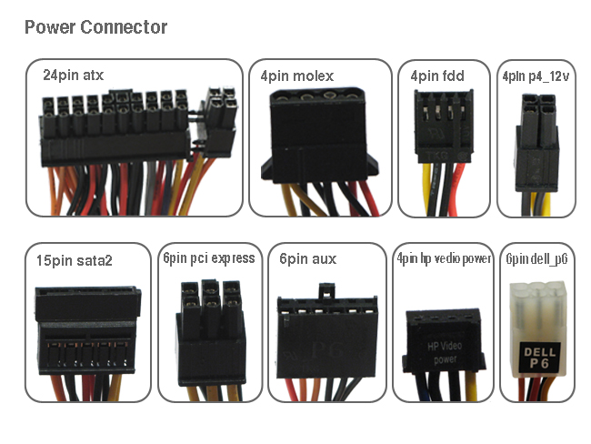

1. **BIOS/UEFI**: Firmware for booting and system management.

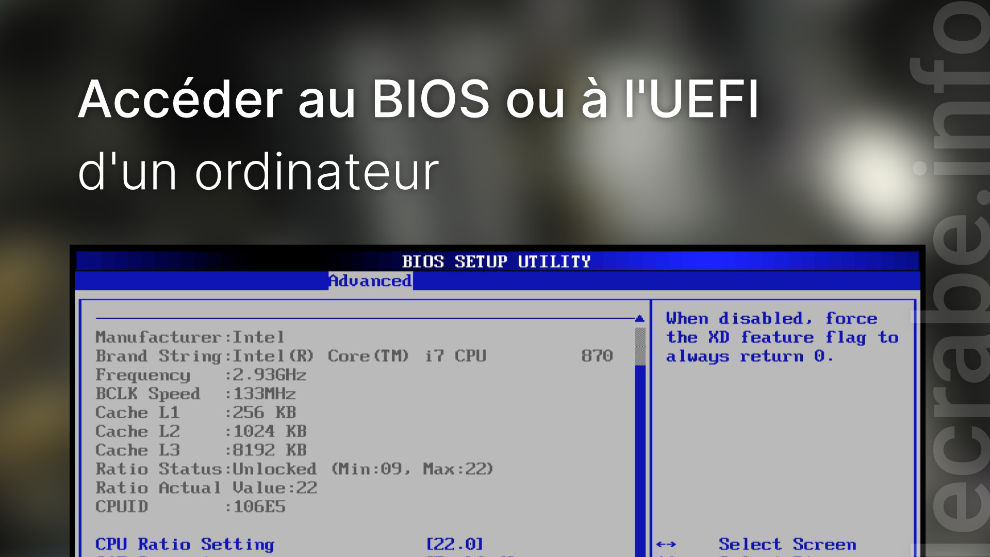

1. **I/O Ports**: USB, HDMI, Ethernet, and audio connectors.

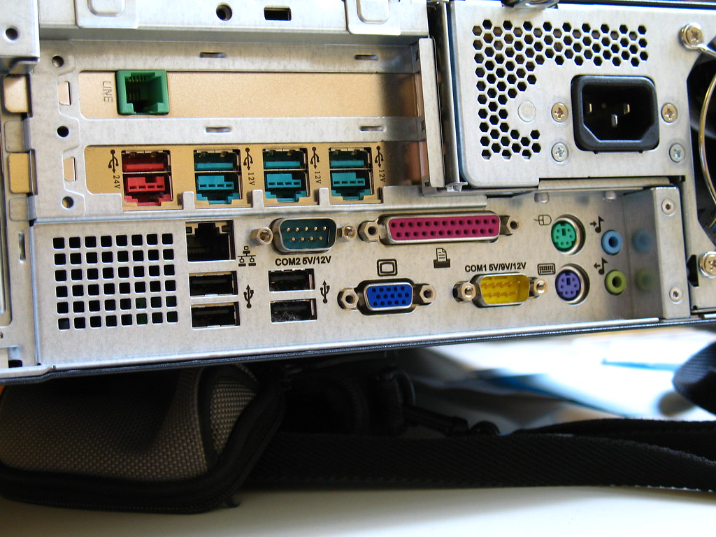

1. **Cooling Headers**: Connectors for CPU and case fans.

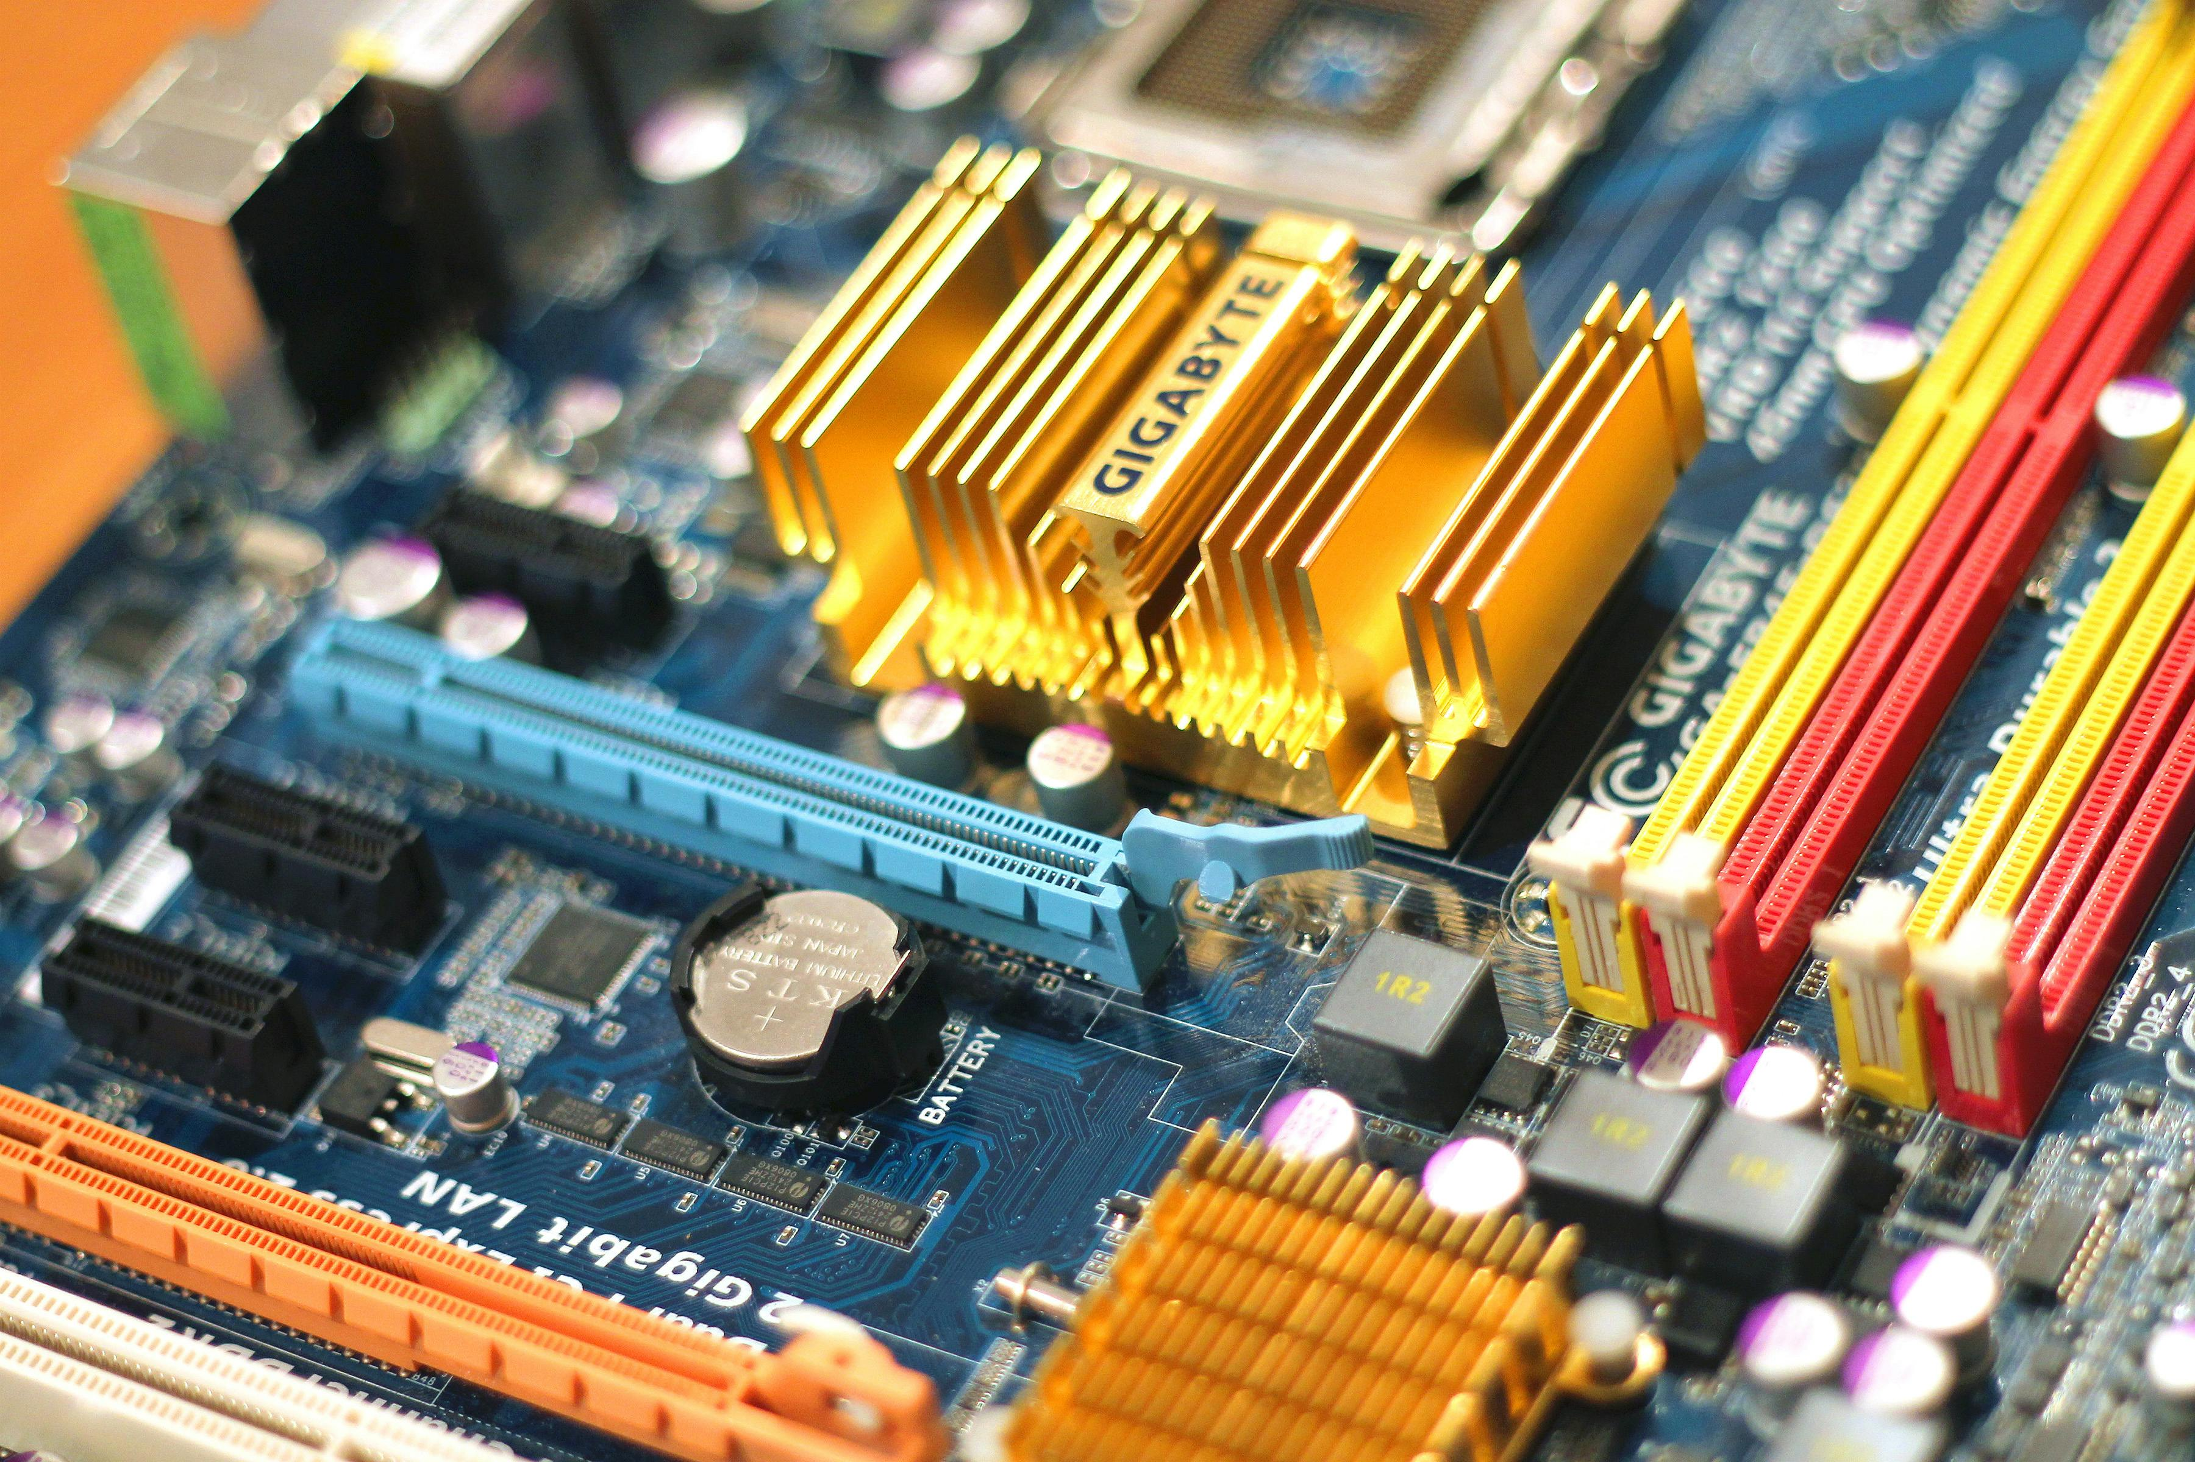

**LAB 4**

**Introduction to MS office, MS Word basic features**

* **Introduction to MS office:**

Microsoft Office (MS Office) is a collection of productivity software applications designed to perform essential tasks such as document creation, data analysis, presentations, and communication. It was developed by Microsoft and is widely used in both professional and personal settings. Its applications are tailored to specific functions and have become industry standards in their respective fields.

* **Key Components of MS office:**

1. **Microsoft Word:** Word processing software for creating text-based documents.
2. **Microsoft Excel:** Spreadsheet software for data analysis and calculations.
3. **Microsoft PowerPoint:** Presentation software for slide-based content creation.
4. **Microsoft Outlook:** Email, calendar, and task management software.
5. **Microsoft Access:** Database management system for storing and analyzing data.
6. **Microsoft Publisher:** Software for designing professional layouts and publications.
7. **Microsoft OneNote:** Digital note-taking application.
8. MS Office is available in two main formats:
9. **Microsoft 365:** Subscription-based, includes cloud integration and collaboration tools.
10. **Standalone Versions:** One-time purchase with limited updates.

* **Introduction to MS Word:**

**Microsoft Word** is one of the most popular word-processing applications in the world. It is designed for creating, editing, and formatting text documents. MS Word is used in various domains, including education, business, and personal projects, because of its versatility and ease of use.

* **MS Word basic features:**

1. **Document Creation and Editing:**
   * Type, edit, and format text with ease.
   * Undo and redo actions for error correction.
2. **Formatting Tools:**
   * **Font Styles and Sizes:** Change text appearance using fonts like Arial, Times New Roman, etc.
   * **Text Formatting:** Options for bold, italic, underline, strikethrough, etc.
   * **Text Color and Highlighting:** Add color to text or highlight important parts.
3. **Paragraph Formatting:**
   * Align text (left, center, right, justify).
   * Adjust line spacing and paragraph spacing.
   * Create bulleted and numbered lists.
   * Indentation tools for structured content.
4. **Page Layout:**
   * Set margins, page orientation (portrait/landscape), and page size.
   * Use columns for newspaper-style layouts.
   * Add headers, footers, and page numbers.
5. **Insert Features:**
   * **Images and Shapes:** Insert and manipulate images, clip art, and shapes.
   * **Tables:** Create and format tables to organize data.
   * **Hyperlinks:** Add links to websites or other parts of the document.
   * **Text Boxes:** Highlight specific content within the document.
   * **Charts and SmartArt:** Visualize data using built-in charts and diagrams.
6. **Templates:**
   * Pre-designed templates for resumes, letters, brochures, and more.
   * Customize templates to suit individual needs.
7. **Review Tools:**
   * **Spell Check and Grammar:** Identify and correct errors.
   * **Thesaurus:** Find synonyms and antonyms.
   * **Track Changes:** Monitor edits made by collaborators.
   * **Comments:** Add notes for feedback or clarification.
8. **Saving and Exporting:**
   * Save files in multiple formats (e.g., .docx, .pdf, .txt).
   * AutoSave feature in Microsoft 365 for real-time saving.
   * Cloud integration with OneDrive for easy access.
9. **Collaboration Tools:**
   * Share documents with others via email or cloud.
   * Real-time editing with multiple users in Microsoft 365.
10. **Accessibility Features:**
    * Read Aloud feature for listening to the document.
    * Accessibility Checker to ensure the document is user-friendly for people with disabilities.
11. **Printing Options:**
    * Print preview for checking layout before printing.
    * Customize print settings like page range and orientation.
12. **Advanced Features:**
    * Add bookmarks, cross-references, and captions for professional documents.
    * Use macros for automating repetitive tasks.
    * Protect documents with passwords.

* **Use Cases of MS Word:**
* **Education:** Writing essays, assignments, and research papers.
* **Business:** Drafting reports, contracts, and proposals.
* **Personal:** Creating resumes, letters, and personal projects.

**LAB 5**

**MS word Advanced features**

* **Advance features of MS Word:**

Microsoft Word offers several advanced features to help users create professional, structured, and efficient documents. Below is an overview of these features, including **Mail Merge**, **Table of Contents**, **Section Breaks**, **References**, and **Headers/Footers**.

1. **Mail Merge:**

**Mail Merge** is a feature that allows users to create personalized documents like letters, emails, and labels by merging a template with a data source.

**Steps to Perform Mail Merge**

* **Start Mail Merge:**
  1. Go to the **Mailings** tab.
  2. Click **Start Mail Merge** and select the type of document (Letters, Emails, Envelopes, etc.).
* **Select Recipients:**
  1. Click **Select Recipients** to choose your data source (Excel sheet, CSV file, Outlook contacts, etc.).
* **Insert Merge Fields:**
  1. Place the cursor where you want personalized data.
  2. Use the **Insert Merge Field** option to add fields like name, address, etc.
* **Preview Results:**
  1. Click **Preview Results** to see how the document will appear for each recipient.
* **Complete the Merge:**
  1. Click **Finish & Merge** to print or save the merged documents.

1. **Table of Contents (TOC):**

The **Table of Contents** feature automatically generates a summary of document headings, making it easier to navigate lengthy documents.

**Steps to create a Table of contents:**

* **Use Heading Styles:**
  + Apply **Heading 1**, **Heading 2**, etc., from the **Home** tab to the headings in your document.
* **Insert TOC:**
  + Place the cursor where you want the Table of Contents.
  + Go to the **References** tab and click **Table of Contents**.
  + Select a pre-designed TOC style or create a custom one.
* **Update TOC:**
  + If changes are made to the document, right-click on the TOC and select **Update Field** to refresh it.

1. **Section Breaks:**

**Section Breaks** divide a document into sections, allowing different formatting (e.g., page layout, headers/footers) within the same document.

* **Types of Section Breaks:**
* **Next Page:** Starts a new section on the next page.
* **Continuous:** Starts a new section on the same page.
* **Even Page/Odd Page:** Begins the section on the next even/odd page.
* **Steps to Add Section Breaks:**
* Place the cursor where the break is needed.
* Go to the **Layout** tab.
* Click **Breaks** and choose the desired type of section break.

**Uses Cases**

* Apply different headers/footers in different sections.
* Use varied page orientations (portrait/landscape) within the same document.

1. **References:**

The **References** feature is crucial for creating professional documents like research papers and reports.

**Key Reference Tools:**

* **Citations and Bibliography:**
* Insert citations for references.
* Go to the **References** tab, click **Insert Citation**, and choose the citation style (APA, MLA, etc.).
* Use the **Bibliography** tool to generate a reference list.
* **Cross-References:**
* Link to other parts of the document (e.g., tables, figures, headings).
* Go to **Insert > Cross-Reference** and select the reference type.
* **Footnotes and Endnotes:**
* Add explanations or citations at the bottom of a page (footnotes) or at the end of the document (endnotes).
* Use the **References** tab and click **Insert Footnote** or **Insert Endnote**.

1. **Header and Footers:**

Headers and footers appear at the top and bottom of every page, respectively, and can include information like titles, dates, and page numbers.

**Steps to Add Header and Footers:**

* Go to the **Insert** tab and click **Header** or **Footer**.
* Choose a built-in style or create a custom one.
* Use the **Header & Footer Tools** to:
* Add page numbers, dates, or document titles.
* Differentiate headers/footers for odd and even pages.
* Use **Link to Previous** to repeat headers/footers across sections or unlink them for unique content.

**Use Cases**

* Add a document title or logo in the header.
* Display page numbers or confidentiality disclaimers in the footer.
* **Tips for Efficient Use:**
* **Combine Features:** Use **Section Breaks** to create different headers/footers for specific sections.
* **Custom Styles:** Format the Table of Contents to match your document's theme.
* **Shortcuts:** Use keyboard shortcuts like Ctrl+Enter for page breaks and Alt+Shift+O to mark TOC entries.
* **Templates:** Save time by using MS Word templates for letters, reports, or newsletters.

**LAB 6**

**Using Mendeley, Grammarly & PDF Element; Macros and Automation**

* **Using Tools like Mendeley, Grammarly, PDF Element, and Macros in MS Word:**

Incorporating third-party tools and advanced automation like macros can significantly improve productivity, especially for academic writing, editing, and managing documents. Below is an overview of how these tools and techniques can enhance your workflow.

1. **Mendeley: Referencing Tools for Citations, Footnotes, and Endnotes:**

Mendeley is a reference management software that simplifies citation and bibliography generation. It integrates seamlessly with MS Word, allowing you to insert and format references efficiently.

**Key Features of Mendeley:**

* Organize references into libraries and folders.
* Automatically generate citations and bibliographies in various formats (e.g., APA, MLA, Chicago).
* Insert citations directly into MS Word.

**Steps to use Mendeley in MS Word:**

* **Install Mendeley:**
  + Download and install Mendeley Desktop.
  + Enable the MS Word plugin during installation.
* **Insert Citations:**
  + Open your document in MS Word.
  + Navigate to the **References** tab, where you'll find the Mendeley plugin.
  + Place the cursor where the citation is required, then click **Insert Citation** in the Mendeley menu.
  + Search for your reference from the Mendeley library or add a new reference.
* **Generate Bibliography:**
  + After inserting citations, click **Insert Bibliography** to generate a reference list at the end of the document.
* **Edit Citation Styles:**
  + Change citation styles (e.g., APA, MLA) using the **Style** dropdown in the Mendeley menu.

1. **Grammarly: Editing and Proofreading:**

Grammarly is an AI-powered tool that enhances the quality of your writing by identifying grammar, spelling, punctuation, and style issues.

**How to use Grammarly with MS Word:**

* **Install the Grammarly Add-in:**
  + Download the Grammarly for Word and Outlook add-in from Grammarly's website.
  + Integrate it into MS Word through the add-ins menu.
* **Proofread Your Document:**
  + Open your document, and Grammarly will automatically scan it for errors.
  + Suggested corrections will appear in the right-hand panel.
* **Accept or Ignore Suggestions:**
* Click on a suggestion to accept or ignore it.

**Benefits:**

* Improves readability and tone.
* Ensures professional-quality writing.
* Provides feedback on word choice and conciseness.

1. **PDF Element: PDF to Word Conversion and Editing:**

PDF Element is a versatile tool for converting, editing, and annotating PDF files.

**Steps for PDF to Word conversions:**

* Open the PDF file in PDF Element.
* Click **Convert** in the top menu and select **To Word** as the output format.
* Save the converted file and open it in MS Word for editing.

**Additional Features:**

* Edit text and images in PDFs.
* Annotate with comments, highlights, and stamps.
* Create fillable forms.

1. **Automation with Macros in MS Word:**
2. Macros are a powerful tool in MS Word for automating repetitive tasks.

**Steps to create and run a Macro**

* **Enable the Developer Tab:**

Go to **File > Options > Customize Ribbon** and check the **Developer** tab.

* **Record a Macro:**

Click **Record Macro** in the Developer tab.

Name the macro and choose whether to assign it to a button or keyboard shortcut.

Perform the repetitive task you want to automate.

* **Stop Recording:**
  + Once done, click **Stop Recording.**
* **Run the Macro:**
  + Use the assigned button or shortcut to run the macro.

**Examples of task to Automate:**

* Formatting text consistently.
* Inserting frequently used text or tables.
* Applying specific styles to headings or paragraphs.

1. **Footnotes and Endnotes for References**

Footnotes and endnotes are essential for adding explanations or citations in professional documents

**Steps to Insert Footnotes and Endnotes in MS Word:**

* Place the cursor where you want the note.
* Go to the **References** tab.
* Click **Insert Footnote** or **Insert Endnote.**
* Type the reference or note content.

**Formatting Options:**

* Customize numbering styles (e.g., Arabic, Roman numerals).
* Adjust placement in the **Footnotes** dialog box under the **References** tab.

1. **Combining Tools for Efficient Workflow:**

* **Mendeley + Word:** Use Mendeley to manage references and insert citations while writing in Word.
* **Grammarly:** Use Grammarly for editing and proofreading your academic or professional documents.
* **PDF Element:** Convert PDF files to Word for editing and use macros to automate repetitive tasks.
* **Macros:** Automate repetitive formatting tasks and standardize your document structure.
* By leveraging these tools and techniques, you can streamline your workflow, improve document quality, and save time on repetitive tasks.

**LAB 7**

**Mail Management, Collaborative Tools & Document Protection**

* **Mail Management in MS Word**

1. **Mail Merge**: Automate the creation of personalized documents like letters, labels, or emails using data from a spreadsheet (e.g., Excel).
2. **Email Integration**: Send documents directly via Outlook or other email clients without leaving Word.

* **Collaborative Tools in MS Word**

1. **Real-time Co-authoring**: Multiple users can edit a document simultaneously if stored in OneDrive or SharePoint.
2. **Comments and Track Changes**: Add feedback using comments, and track document edits made by collaborators.
3. **Version History**: Access previous versions of a document and restore earlier drafts.

* **Document Protection in MS Word**

1. **Password Protection**: Set a password to restrict access to the document.
2. **Restrict Editing**: Limit the types of edits (e.g., only allow filling in forms).
3. **Digital Signatures**: Add a secure digital signature to verify the authenticity of the document.
4. **Restrict Formatting**: Control which styles or formatting changes can be applied.

### **Mail Management**

Mail management involves efficiently handling and organizing email communication within an organization or for personal use. It ensures timely responses, secure storage, and minimal clutter.

#### **Key Features:**

* **Email Filtering:** Automatically sorts emails into folders based on rules.
* **Archiving:** Stores older emails for future reference while keeping the inbox clutter-free.
* **Spam Protection:** Filters out unwanted emails.
* **Integration with Tools:** Links with calendars, task managers, or customer relationship management (CRM) systems.
* **Security:** Protects against phishing, malware, and unauthorized access.

#### **Popular Tools:**

* **Microsoft Outlook**
* **Gmail**
* **Zoho Mail**

### **2. Collaborative Tools**

Collaborative tools enable teams to work together, share ideas, and manage projects efficiently, even remotely.

#### **Key Features:**

* **Real-Time Editing:** Allows multiple users to edit documents simultaneously.
* **Project Management:** Tracks tasks, deadlines, and milestones.
* **Communication:** Includes chat, video calls, and discussion boards.
* **File Sharing:** Facilitates the sharing and co-editing of files.
* **Integration:** Connects with other productivity tools.

#### **Popular Tools:**

* **Microsoft Teams**
* **Slack**
* **Google Workspace (Docs, Sheets, Drive)**
* **Asana** and **Trello** (for project management)

### **3. Document Protection**

Document protection ensures that sensitive files are secure from unauthorized access, tampering, and accidental loss.

#### **Key Features:**

* **Encryption:** Protects documents with advanced encryption algorithms.
* **Access Control:** Sets permissions for viewing, editing, or sharing.
* **Watermarking:** Adds a watermark to deter unauthorized sharing.
* **Version History:** Tracks changes and allows restoration of previous versions.
* **Backup Solutions:** Prevents data loss with automatic backups.

#### **Popular Tools:**

* **Adobe Acrobat Pro**
* **Microsoft Office 365 (with Azure Information Protection)**
* **Google Drive (with advanced sharing permissions)**
* **DocuSign** (for secure e-signatures)

**MS Excel Lab Assignment**

**Product rule:**

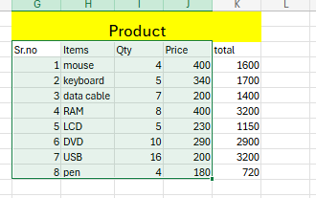

**Sum Rule:**

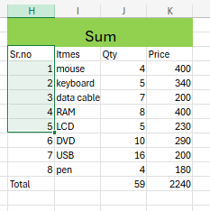

**Proper rule**

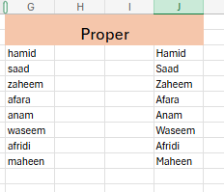

**Maximum rule**

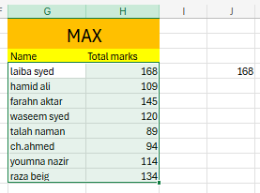

**Minimum rule**

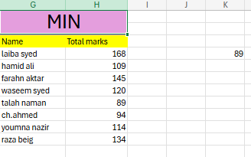

**Large rule**

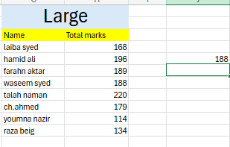

**Small rule**

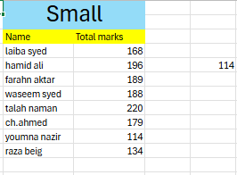

**Today formula**

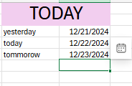

**Time**

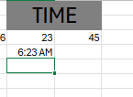

**Current time and date**

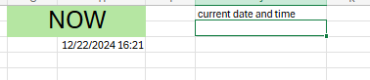

**Delete blank cells in a table**

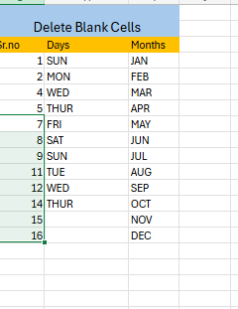

**Len formula (to count the number of characters in a cell)**

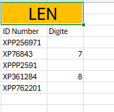

**Count formula (use to count numerical data)**

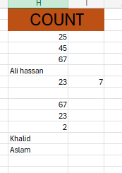

**Counta formula( counts both numerical and alphabetic data)**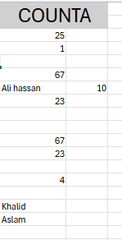

**Countblank (count blanks cells )**

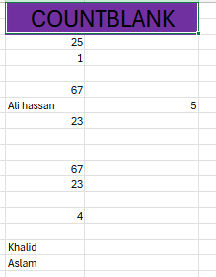

**Concatenate formula**

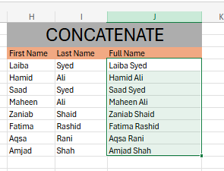

**Countif formula**

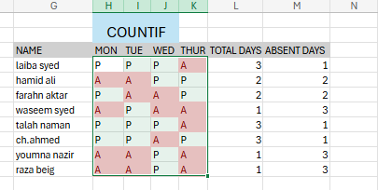

**Sum product rule**

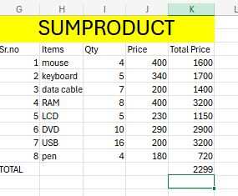

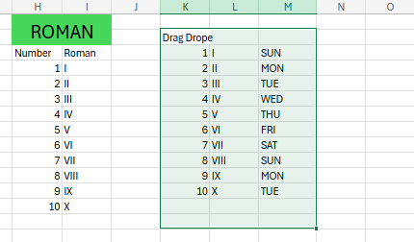

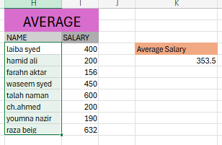

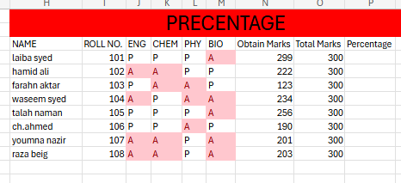

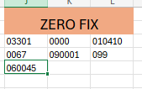

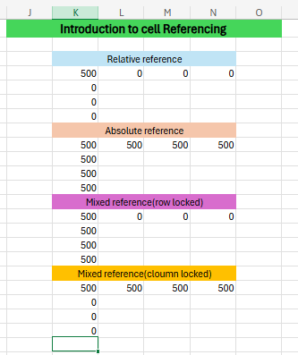

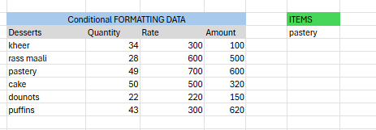

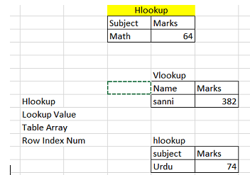

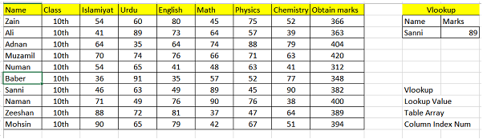

**Qr code**

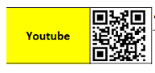

**Bar code**

